Batch Firmware Upgrade

**Objective:**

To execute the scheduled Upgrade of firmware in 1000 devices. This 1000 device will be processed in batch chunk of 200 devices each and each batch will be processed at scheduled date. Task is to notify each device for upgrading there firmware.

**Microservice Details:**

1. **Batch Orchestrator Service**: Orchestrate the other micro services (Create Update Delete Fetch - Entities), has Job reader for reading the batch chunk and will invoke process of each chunk.

Rest End points: None

1. **Batch Data Service**: Is responsible for data connectivity and will provide API for database operations. **Use spring data.**

Rest End points:

bds/fetchBatchChunk : for fetching the chunk id which Is scheduled for upgrade

bds/fetchDeviceList/$chunkId : for fetching the devices from that chunk

bds/updateDevice/$chunkId : for updating the device upgrade status

1. **Batch Executor Service**: responsible for Execution of process of upgrading the devices in chunks (Batches).**Use multithreading for processing the devices.**

Rest End points:

bes/upgrade/$chunkId : for processing the chunk of devices and just printing device notified with device id.

1. **Batch Listener Service:** responsible for Listening the response and will update the device status Response is basically success/failure of upgradation process on the peer device.

Rest End points:

bls/statusFromDevice/$deviceId/$status : for updating the device firmware update status

**microservices with SpringBoot and should be dockerized**

**Database:** Any SQL Database

**Spring eureka for registering all services.**

Using additional spring cloud technologies/additional validations are welcomed.

**API/Architecture details**

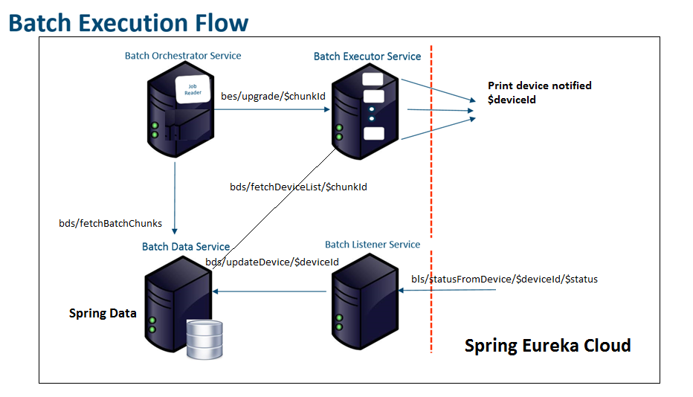

**Table Structure**

Table: **Batch Details**

|  |  |
| --- | --- |
| Column | Type |
| chunkId – PK | String |
| scheduledDate | Date |
|  |  |
|  |  |

Table: **Device Details**

|  |  |
| --- | --- |
| Column | Type |
| deviceId – PK | String |
| chunkId - FK | String |
| statusOfUpgrade | Boolean |
|  |  |